|  |  |
| --- | --- |
| **Canon EOS 5D Mark IV Camera**  Canon EOS 5D Mark IV 1 Canon EOS 5D Mark IV Canon EOS 5D Mark IV 3 Canon EOS 5D Mark IV 2 | **Featured information:**   * Sensor: Full-Frame * ISO range: 100 - 32000 (expanded 50 - 102400) * Resolution: 30.4MP * Wireless connection: WiFi   **Price:** 1600$  **Specifications:**   * **Sensor Format:** Full-Frame (1x Crop Factor) * **Resolution:** 31.7 Megapixels * **Size photo:** 6720 x 4480 * **Image Proportions:** 1:1, 3:2, 4:3, 16:9 * **Sensor Type:** CMOS * **Image Format:** JPEG, Raw * **Anti-Vibration:** No * **Lens Mount:** Canon EF |

**Description:**

**Breakthrough technology inside familiar design**

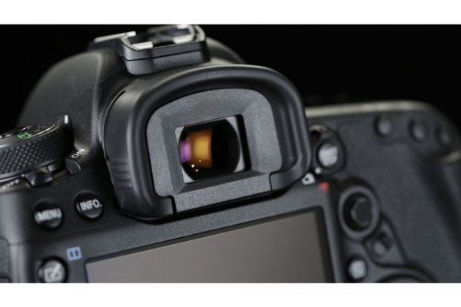

**Touch screen**

The Canon EOS 5D Mark IV has a large 3.2-inch LCD touch screen with 1.62 million pixels and an anti-reflective layer that helps display truly excellent outdoor images.

